Milestone One

Ryan Manchanthasouk

Southern New Hampshire University

March 23rd, 2019

Creating a Database

The first step to creating my database was to figure out what algorithm to use. To do that, first the database had to be created. Afterwards, tables with correct column data would have to be entered.

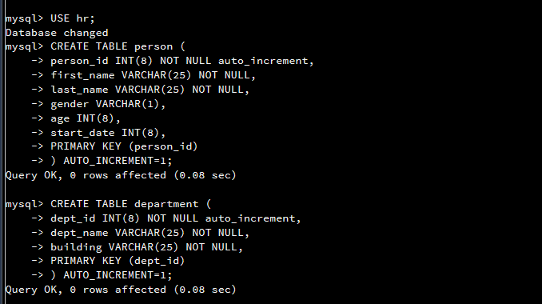

The next step would be to verify that the information was entered correctly. This includes the database name, table names, column values, the type, whether there was an increment, not null or default null, and the correct primary id. It was very important to follow best practices when typing the code. Additionally, being organized and creating things in a systematic order made things very easy to list out and verify all of the values.